Server web server with other services.

Tasks

1. Install Apache web server and PHP on your Linux machine, then create an index.php file that displays 'Welcome to My Foodie Blog' when accessed via your browser.

ANS:

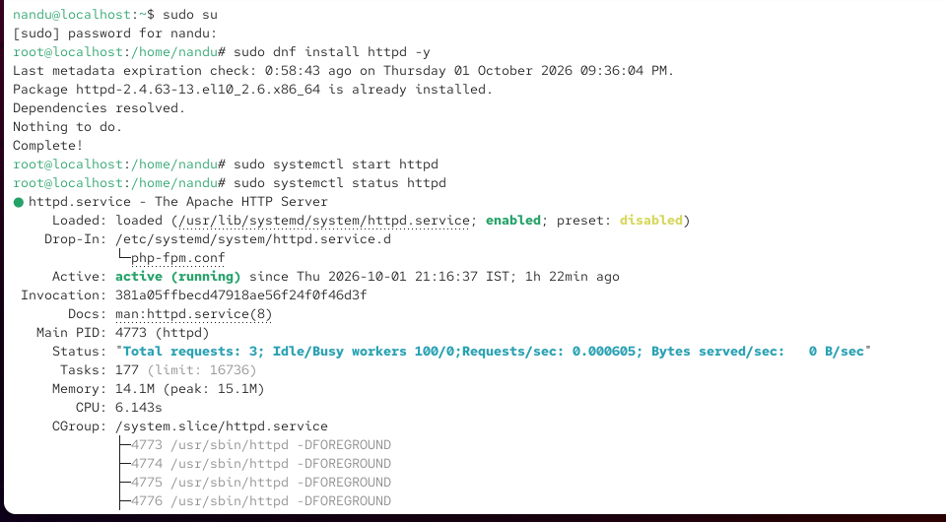

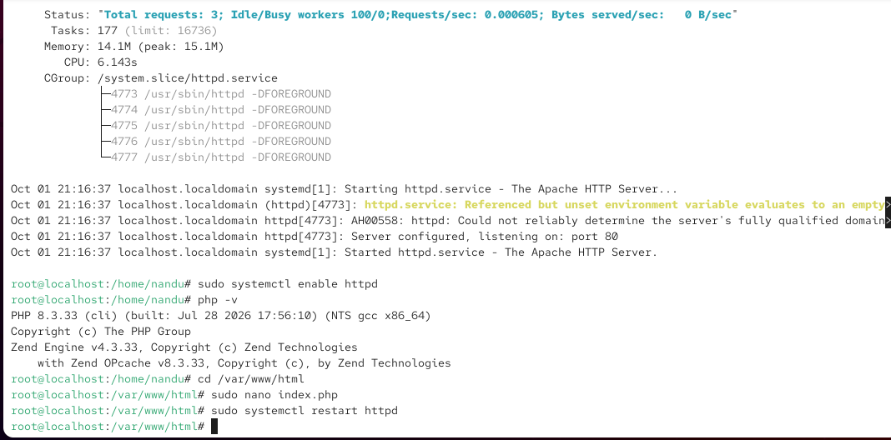

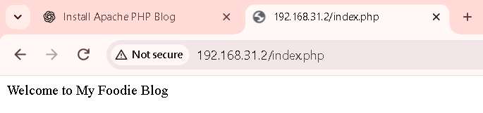

2. Configure your Apache server to serve a custom 404 error page that displays a Zomato-style message: 'Oops! This page is as empty as your cart.'

ANS:

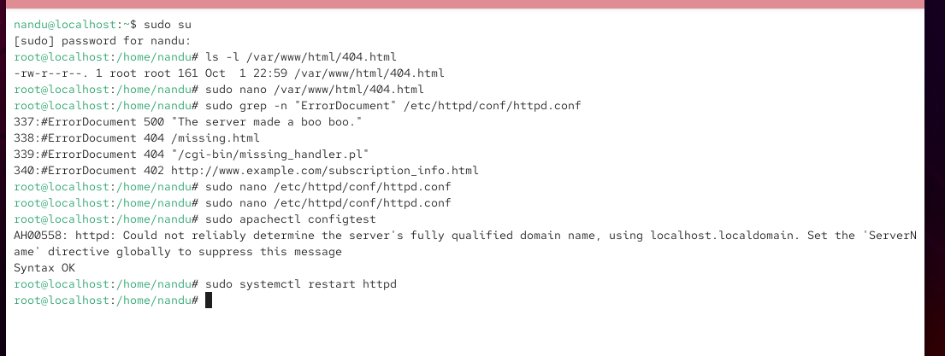

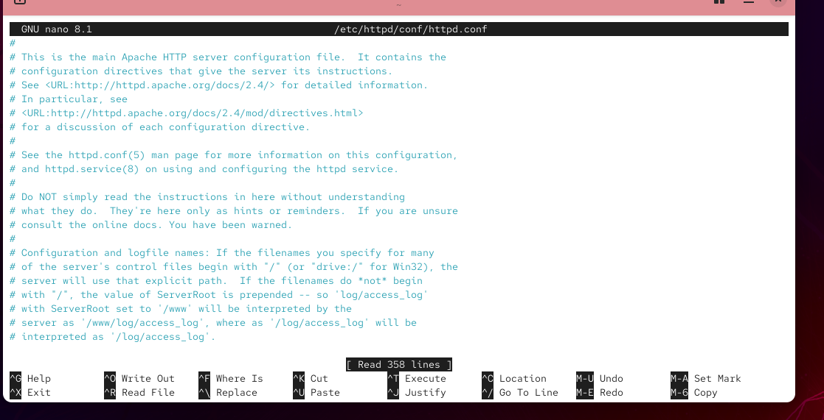

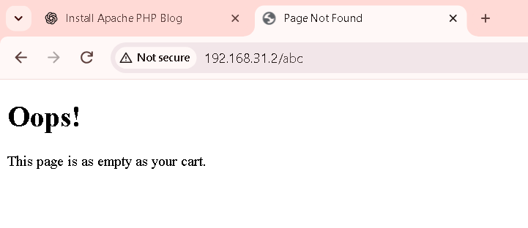

3. Set up a simple FTP server (vsftpd or any other) on your Linux system and upload a sample image file to your web server's root directory using an FTP client.

ANS:

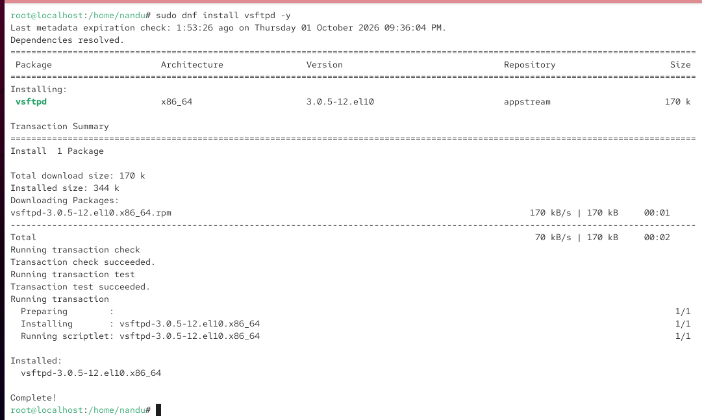

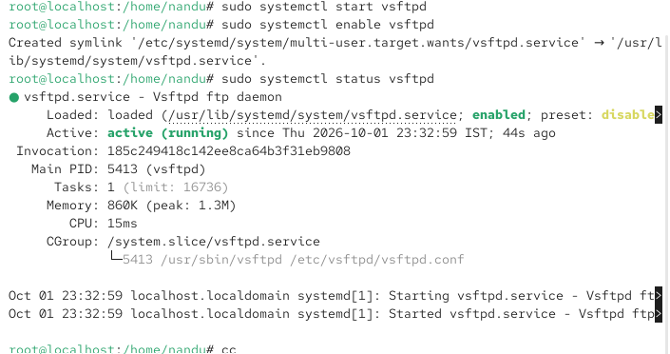

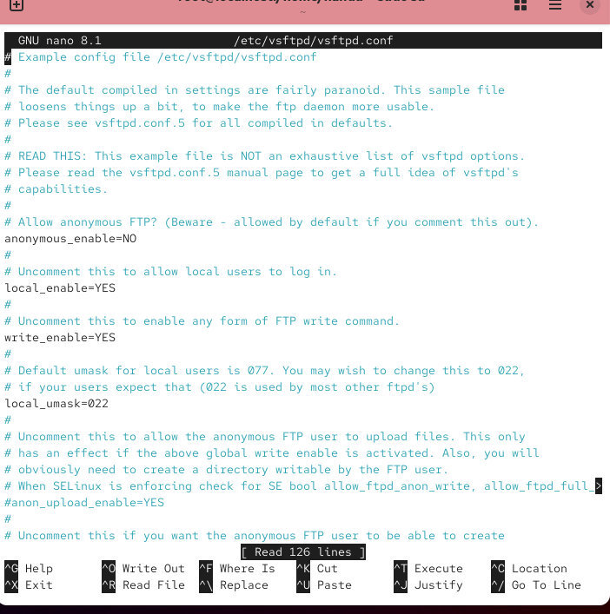

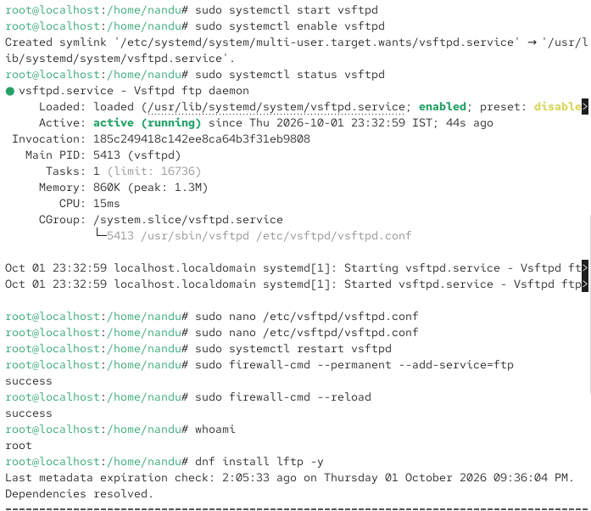

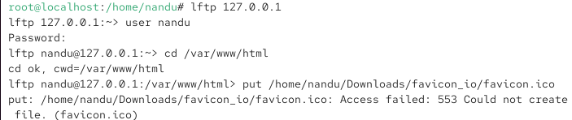

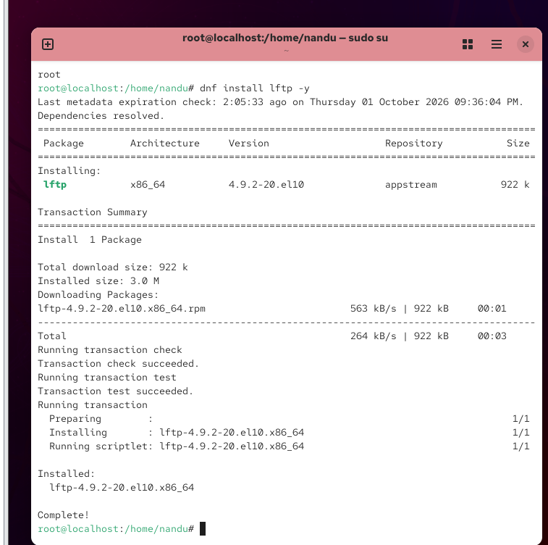

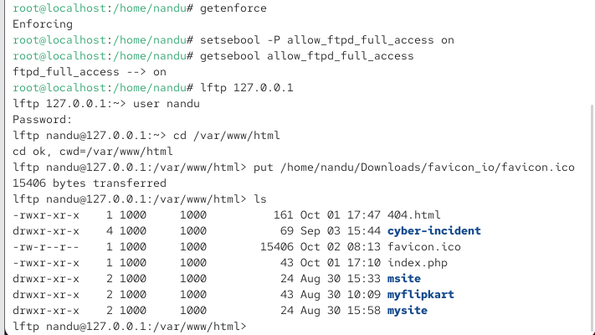

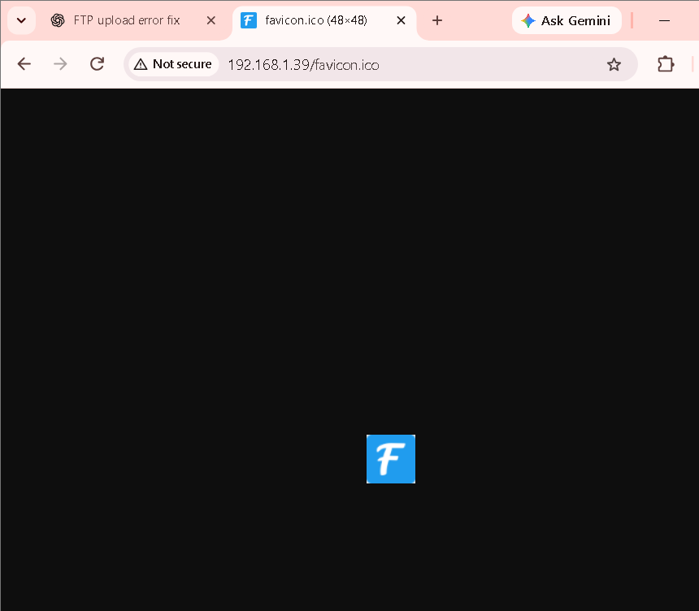

4. Configure your web server to also run a basic Node.js service on a different port (e.g., 3000) that returns JSON data for a mock 'Now Playing' playlist, similar to Spotify. Test accessing both the PHP web page and the Node.js playlist endpoint from your browser.

ANS:

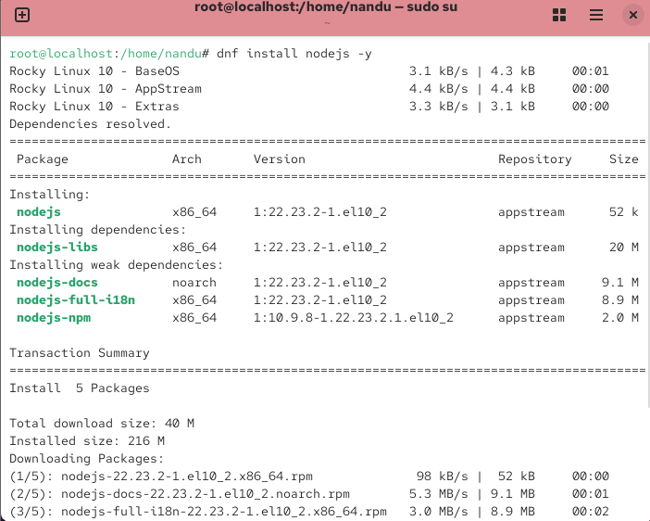

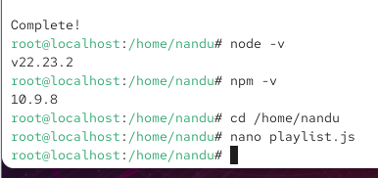
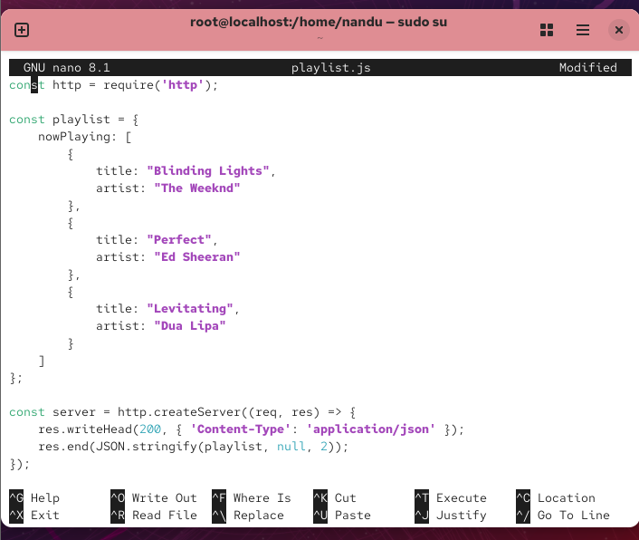

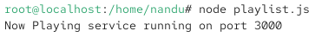

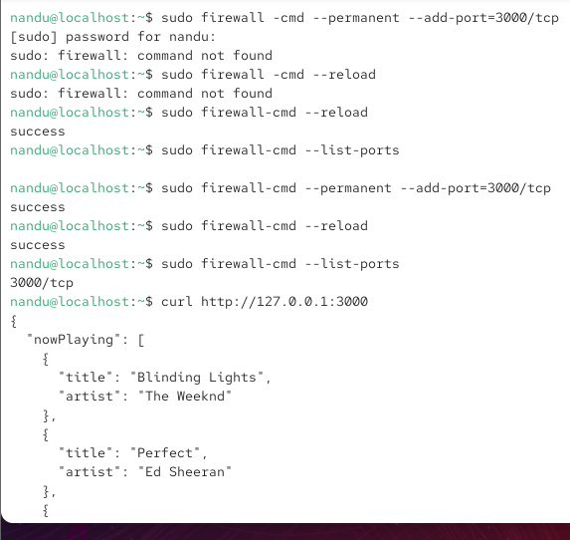

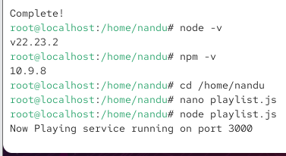

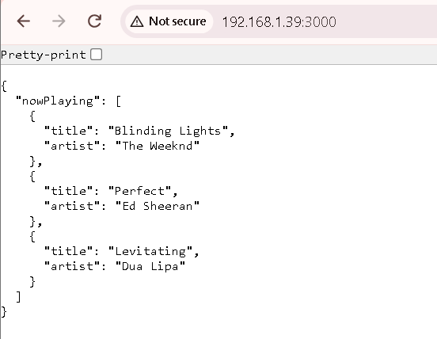

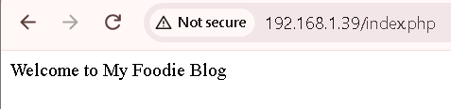

5. Edit your Apache configuration to restrict access to a specific directory (e.g., /var/www/html/secret) so that only users from localhost (127.0.0.1) can access it. Use the 'Require' directive in your Apache config or .htaccess file.

ANS:

